**J.O.F Customs Brokerage: A Web-Based Online Transaction Service System for the Brokers of**

**J.O.F Customs Brokerage**

A Complete Software Requirement Specifications

Version 1.0

**Introduction**

JOF Customs Brokerage is a brokerage company that specializes in the exchange of goods that is imported or exported from the country. Through the years they have served various customers and made a name for themselves, but with the fast paced evolution of technology, people are now expecting transactions to be faster than before, and with the current situation of JOF customs brokerage, their man power cannot compete with the equipped technology of other brokerage company also different brokerage companies have adapted to the technology to further enhance their service capabilities, and so, we have come up with a proposition to create an online automated transaction service system for JOF Customs Brokerage to enhance their services, with the help of this web application communication and transactions will be faster, customers will not be anxious as to the situation of their products because they are updated when every step has been successfully completed, scheduling for a company visit or a meeting will not be a hassle anymore because the brokerage company is notified immediately by the admin if there are requested appointments set by a costumer. This system would also be beneficial to the brokers of JOF Customs Brokerage because the web application can enhance the service satisfaction of the customers.

**System Description**

J.O.F Customs Brokerage Online Transaction Service System is a web based application that will enhance the services and transaction of the company and the client. The system will have two (2) users: Customer which can – create and update an account, schedule a meeting, track the current status of the cargo, and read transaction history – and Admin which can – create and update their account, read and customer transaction history, and delete account if necessary, they are also responsible for updating a specific customer about the status of its product/ cargo

Types of Users:

**Admin/Broker** – Create and update account, read account information, delete account, monitor and update customer of the current status of the product

**Consignee** – Create and Update account, can read transaction history, schedule a meeting, track cargo status, avail services- Import/Export Services.

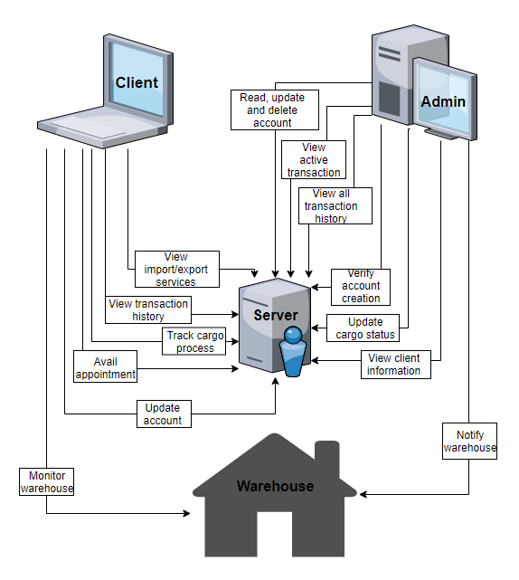**Design Model**

This web application implements a digital approach in handling transactions and monitoring cargo within the company of JOF Customs Brokerage. This application will let the broker/admin create, read, update and delete their account as well as create, read, and delete a client’s account for them to be able to familiarize themselves with their client. Admins can verify the accounts that are pending for clients to be fully registered. They can also update the cargo status of an existing transaction for the client to be able to track the current status of their cargo. For the client’s side, A Client can log in through their account and view the complete information about the content of their cargo together with the information of the broker in-charge. Aside from that, they can also view the Import and Export services offered by the brokerage and avail for an appointment with the company. Lastly, clients are able to view their transaction history in case of record mismatch and such.

**System Flow/Development Process**

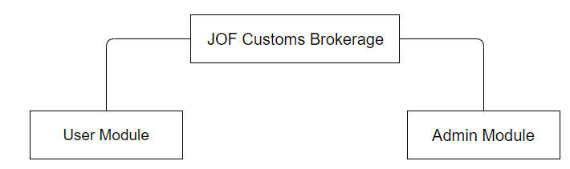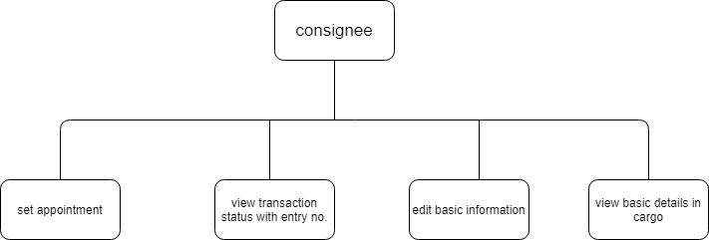

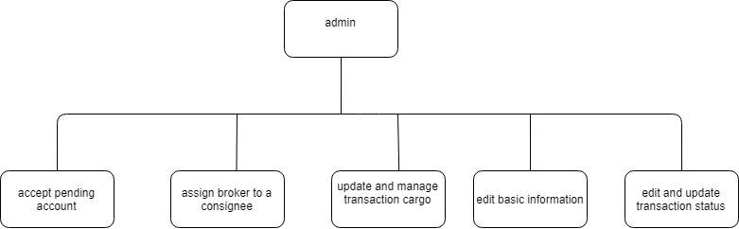

1. 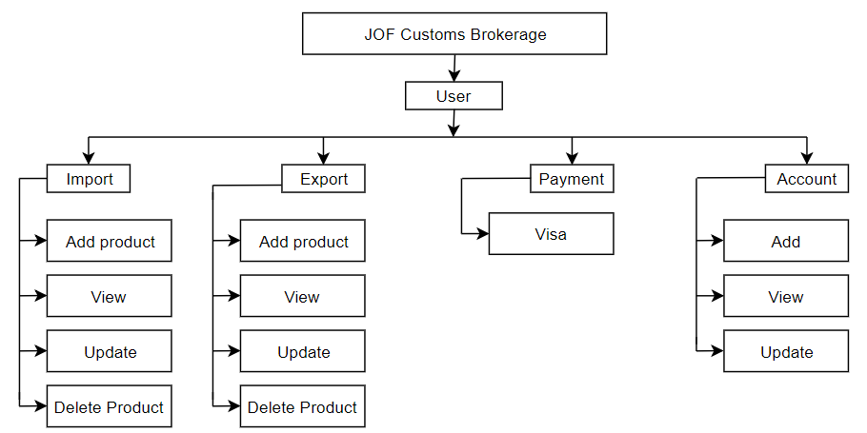**User Module** – enables the user to import and export cargo online and they can also edit their profile/account.
2. 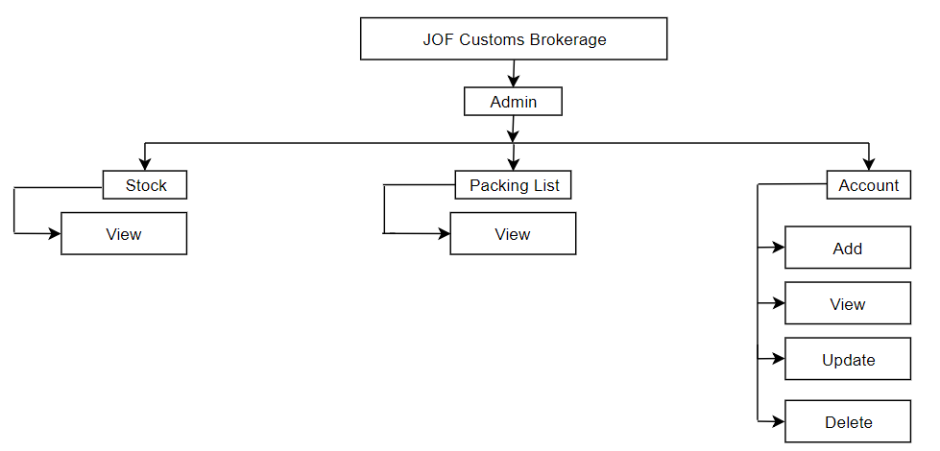**Admin Module** – the admin will verify the customer’s account when signing up and can also manage or monitor the whole system.

**Use Case Diagram**

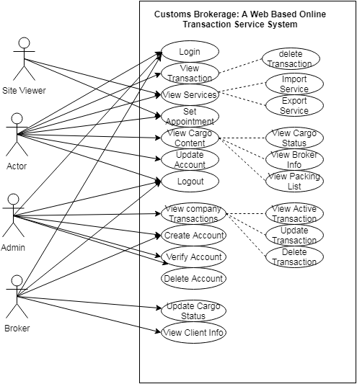

**Wireframe of J.O.F Customs Brokerage: A Web-Based Online Transaction Service System for the Brokers of J.O.F Customs Brokerage**

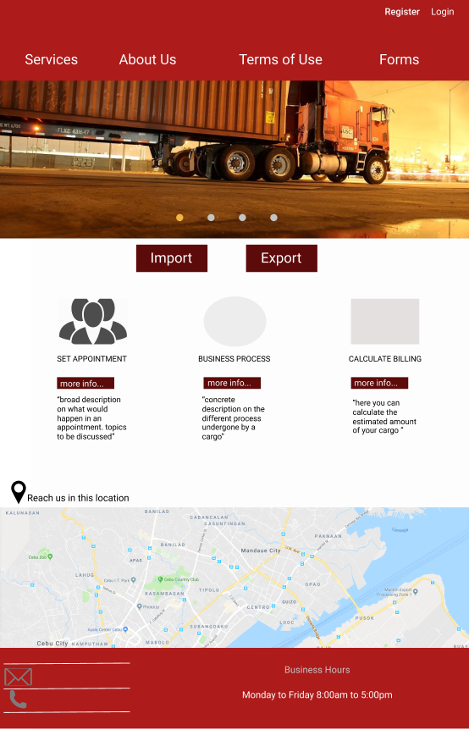

**Home Page**

1. **Register** **Button-** When clicked; link redirects new user to registration form.
2. **Login Button-** When clicked; link redirects user to enter username and password.
3. **Services-** When clicked; it redirects user to the types of services offered by the company.
4. **About Us-** when clicked; it redirects user to the company’s about page.
5. **Terms of Use-** serves as an agreement between user and company
6. **Forms-** When clicked; it redirects user to the list of downloadable forms
7. **Import Button-** When clicked; a pop up will appear asking if user has the specific requirements listed.
8. **Export Button-** When clicked; it shows the gps location of the company.
9. **More Info Button(Set Appointment)-** when clicked; it shows more information on how to set an appointment.
10. **More Info Button(Business Process) -** when clicked; it shows more information on the company’s business process.
11. **More Info Button (Calculate Billing)-** when clicked; it shows more information on how to calculate billing.
12. **Contact –** this lets user to contact the company through their facebook or phone number.

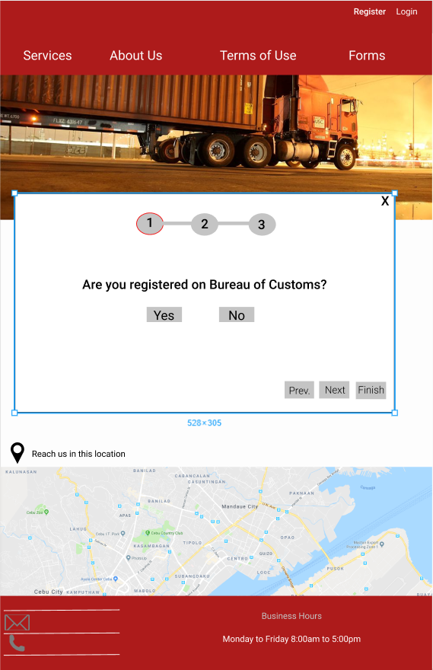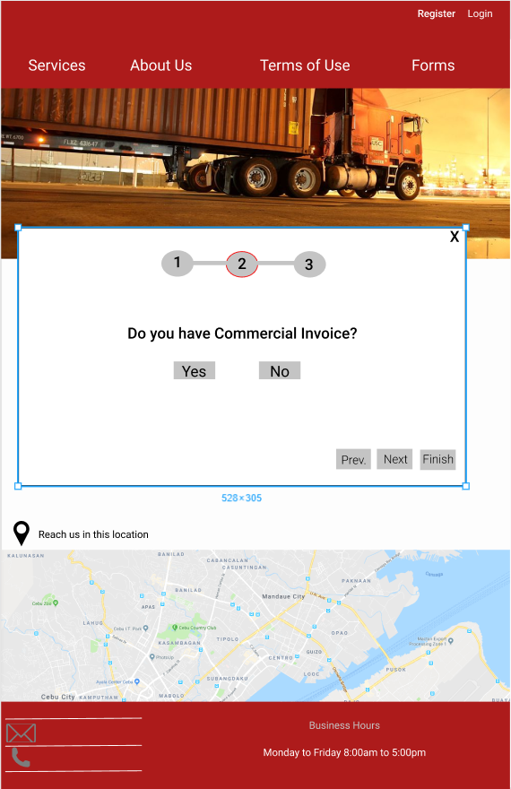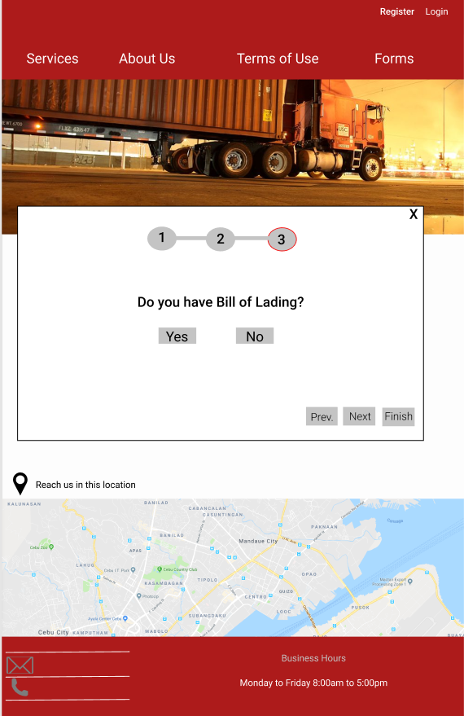

**Import Requirements Pop-Up**

1. **Import Requirement Pop-Up-** This consists 3 steps that asks a user t and check if it has all the requirements before proceeding.
2. **Page One-** the page wherein it asks the user if he/she is registered to Bureau of Customs.
3. **Yes Button-** when clicked; the user will have a check mark for being registered in the Bureau of Customs on the summary of requirements checklist after completing the 3 steps.
4. **No Button-** when clicked; the user will have an x mark for not being registered in the Bureau of Customs on the summary of requirements checklist after completing the 3 steps.
5. **Navigation Button-** thislets user togo back, proceed to the nextprocess or finish the process right away**.**
6. **Page Two-** the page wherein it asks the user if he/she has a Commercial Invoice.
7. **Yes Button-** when clicked; the user will have a check mark for having a commercial invoice on the summary of requirements checklist after completing the 3 steps.
8. **No Button-** when clicked; the user will have an x mark for not having a commercial invoice on the summary of requirements checklist after completing the 3 steps.
9. **Page Three-** the page wherein it asks the user if he/she has a bill of lading.
10. **Yes Button-** when clicked; the user will have a check mark for having a bill of lading on the summary of requirements checklist after completing the 3 steps.
11. **No Button-** when clicked; the user will have an x mark for not having a bill of lading on the summary of requirements checklist after completing the 3 steps.

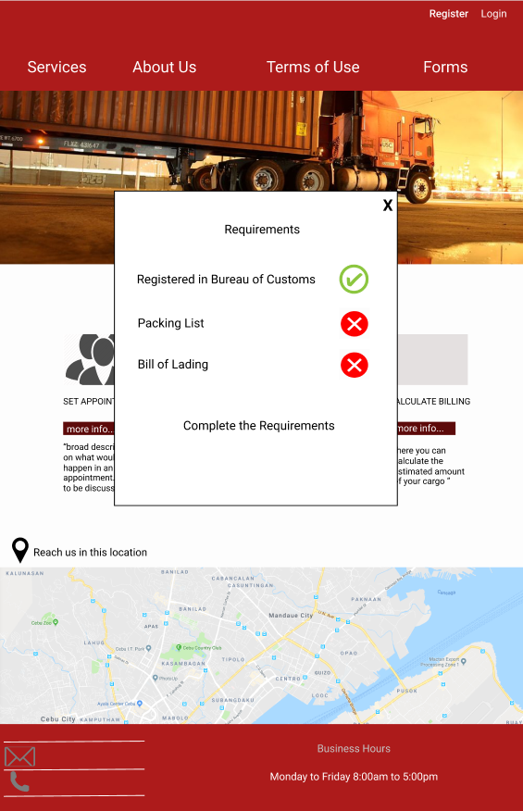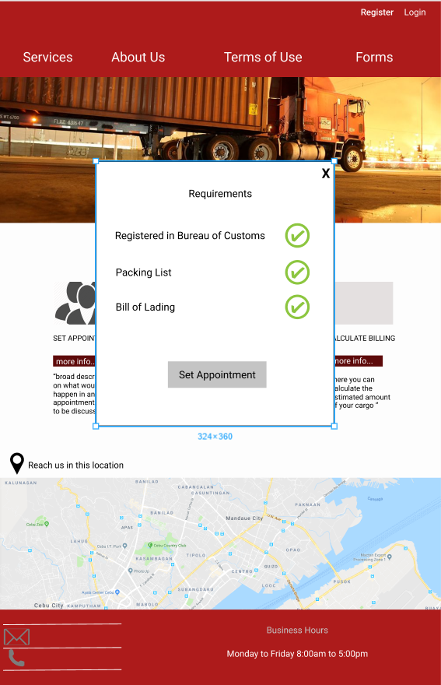

**Import Requirements Checklist**

1. **X Mark-** this means that the user should complete the said remaining requirements before proceeding in setting an appointment.
2. **Check Mark-** this means that the user already has the said requirement/s but is only able to proceed in setting an appointment if all 3 requirements are achieved**.**
3. **Set Appointment Button-** when clicked; user will be redirected to the set appointment form**.**

**Set Appointment Form**

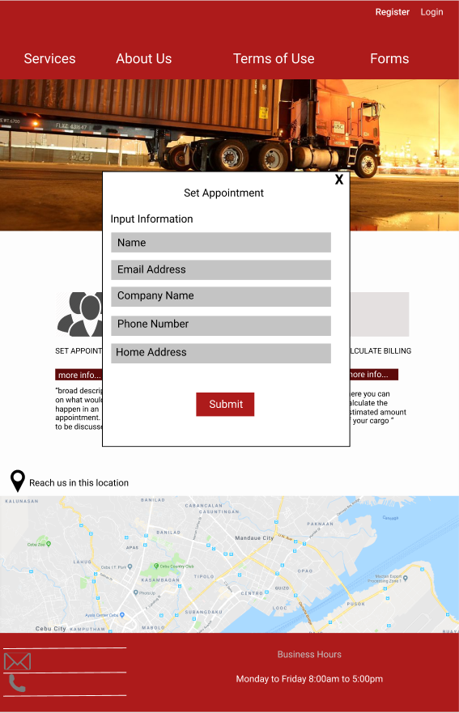

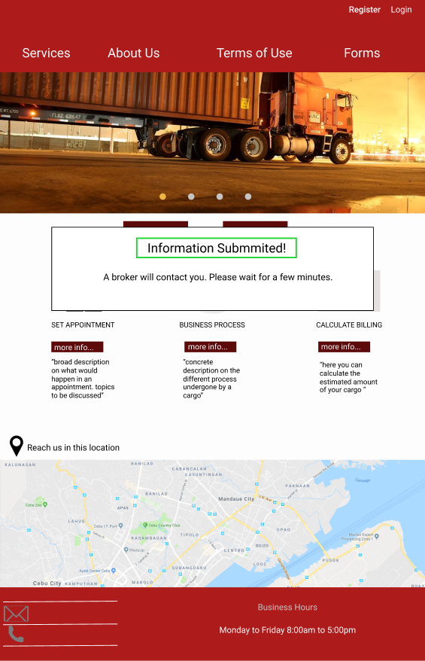

**Set Appointment Form**

1. **Full Name Textbox-** the user will input his/her full name.
2. **Email Textbox-** the user will input his/her valid email address.
3. **Company Name-** the user will input the company name.
4. **Phone Number-** the user will input his /her phone number.
5. **Home Address-** the user will input his/her home address.
6. **Submit Button-** when clicked; user already submitted the form.
7. **Information Submitted Pop up-** this tells the user’s information has been submitted and will be contacted by a broker.

**Sign Up Form (Consignee)**

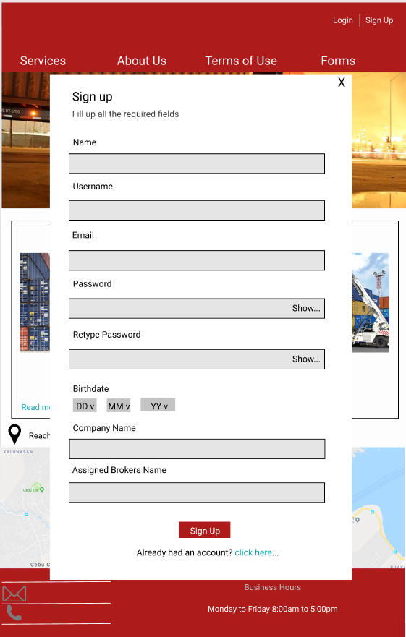

1. **Full Name Textbox-** user will input his/her full name.
2. **Username Textbox-** user will input his/her chosen username.
3. **Email Textbox -** user will input his/her email address.
4. **Password Textbox -** user will input his/her password.
5. **Retype Password Textbox-** user will re-input his/her password.
6. **Birthdate Dropdown-** allows user to choose his/her birthdate details.
7. **Company Name Textbox-** user will input company name.
8. **Assigned Broker’s Name Textbox -** user will input his/her assigned broker’s name.
9. **Signup Button-** when clicked; user is registered successfully.

**Login Form (Consignee)**

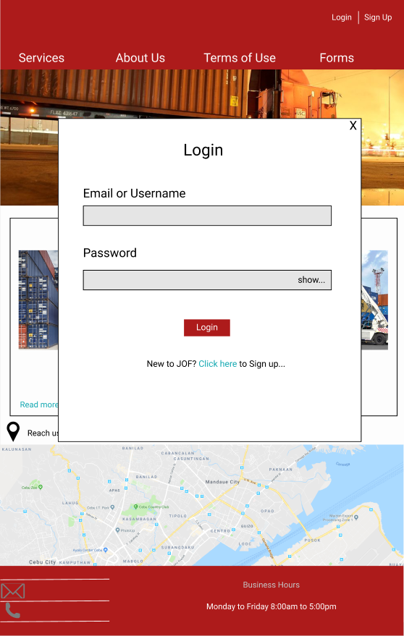

1. **Email or Username Textbox-** user will input his/her username or email.
2. **Password Textbox-** user will input his/her password.
3. **Login Button-** When clicked; user will be logged in and redirected to his/her profile.
4. **Click here hyperlink-** when clicked; it will redirect user to the signup form.

**User Profile (Consignee)**

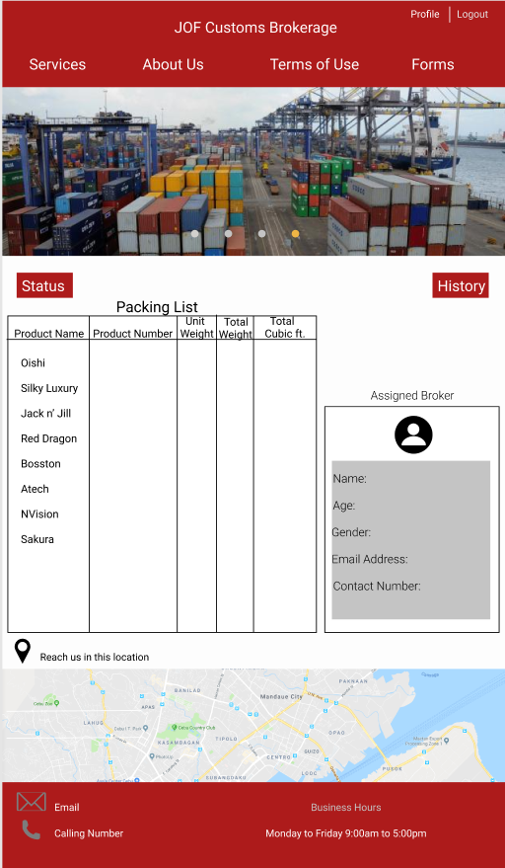

1. **Logout Button-** when clicked; user will be logged out of his/her account.
2. **Status Button-** when clicked; a pop up will show the checklist of the processes that the shipment has gone through.
3. **History Button-** when clicked; a pop up will be shown containing the history of transactions made by the user.
4. **Packing List**- it shows the details of the packing list.
5. **Assigned Broker Profile-** it shows the information of the user’s assigned broker.



**Profile Edit (Consignee)**

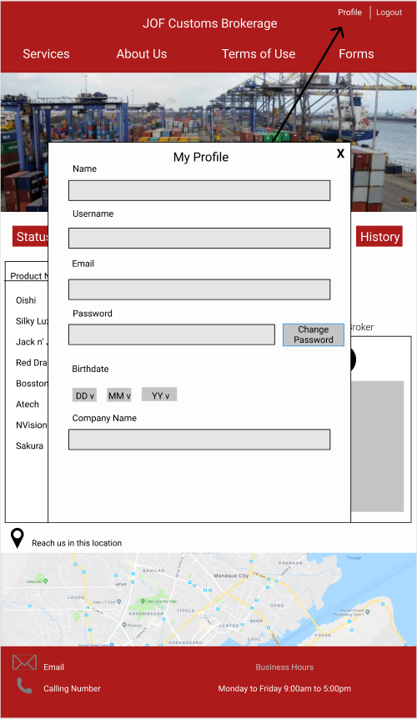

Consignee may edit information in order to make changes in his/her profile.

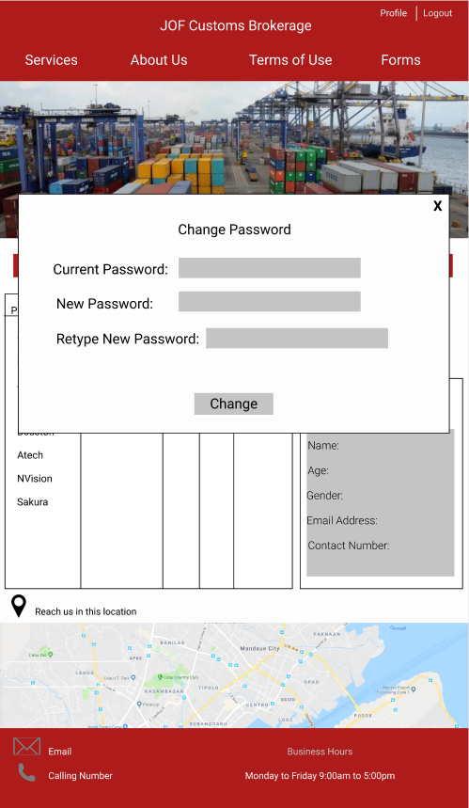**Change Password(Consignee)**



Consignee can edit/make changes to his/her password.

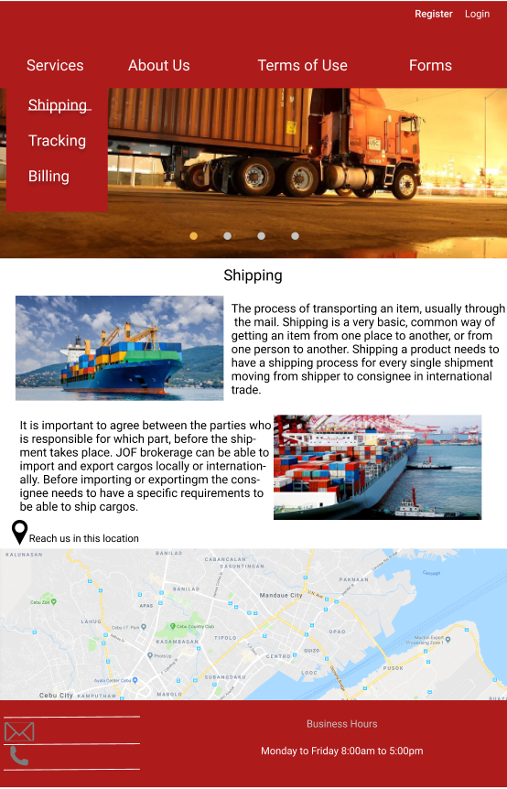**Shipping Page**

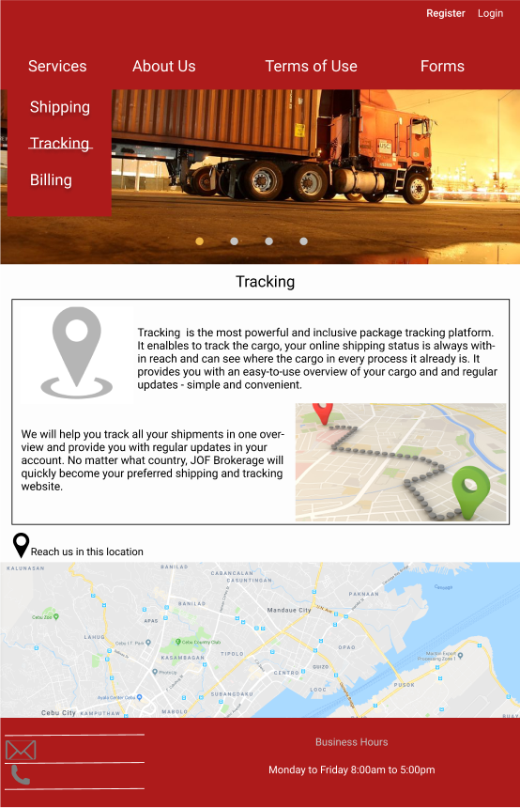**Tracking Page**

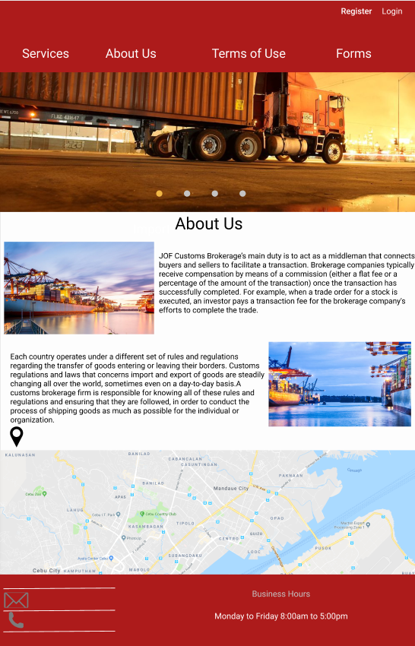**About Us Page**

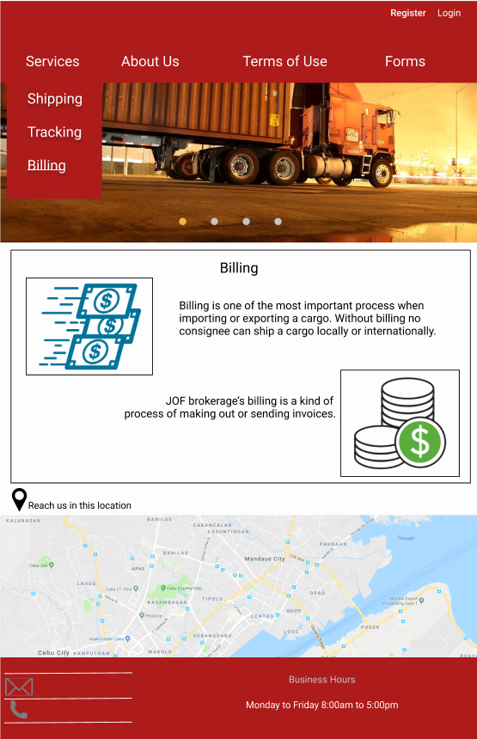**Billing Page**

**Terms of Use Page**

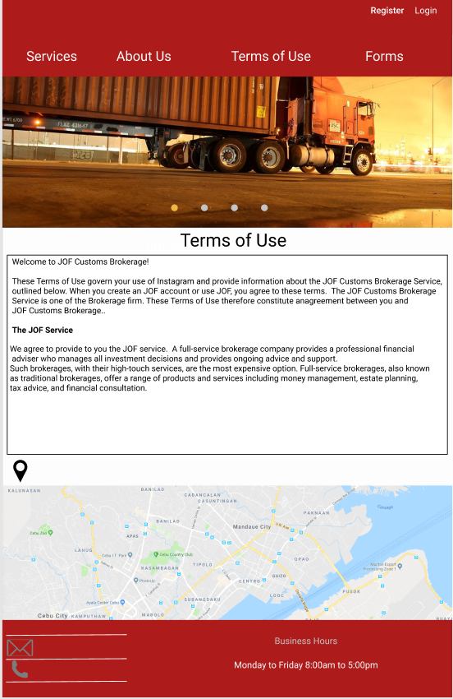



A description of the company’s terms of use.

**Forms Page**

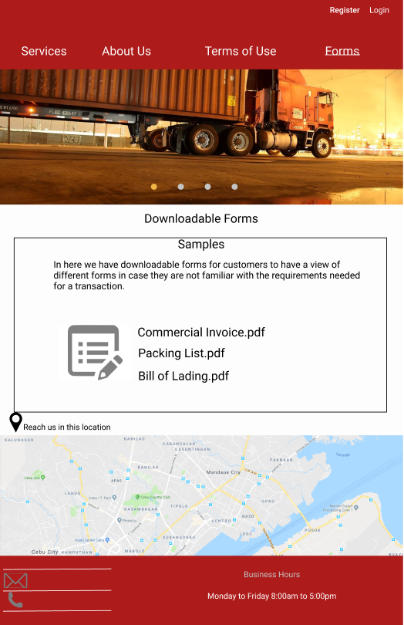



User may download the following sample pdf files to have an idea what type of requirements need before making a transaction.

**Status Pop-Up(Consignee)**

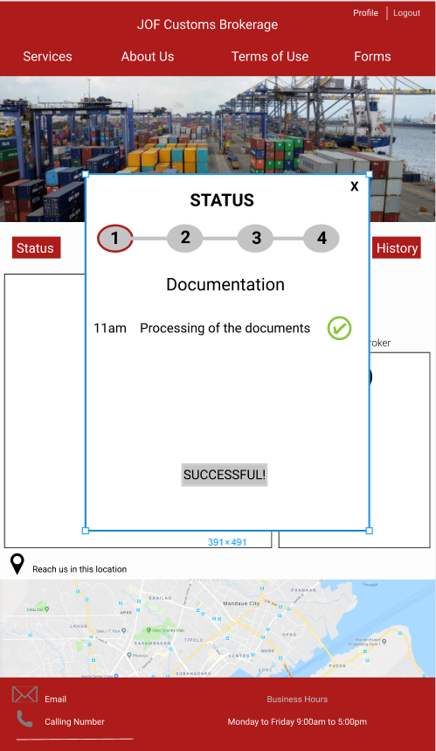

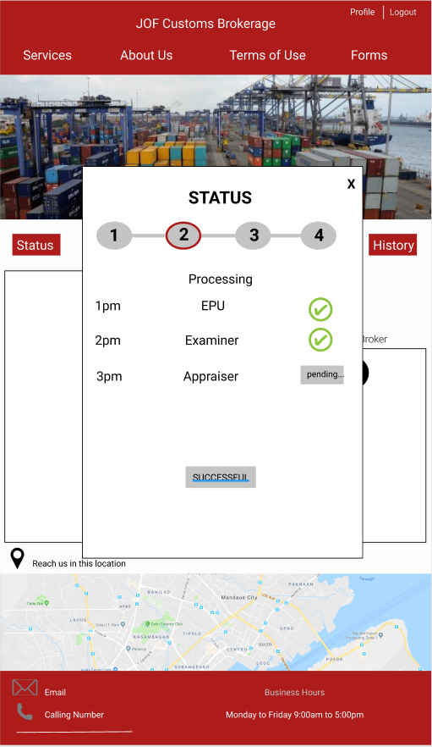

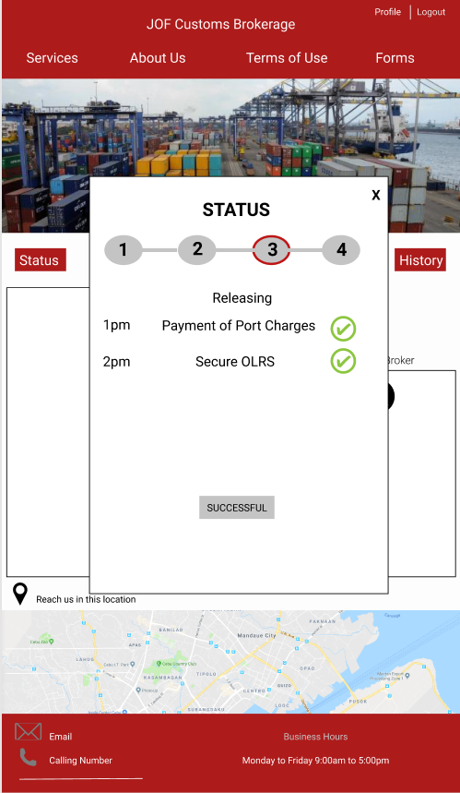

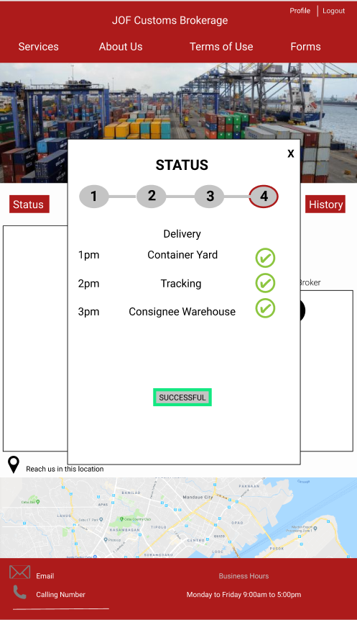

1. **Documentation Status**- it contains the status of documentation
2. **Documentation Status Checklist-** denoted with a check mark to indicate if the process of documentation is complete.
3. **Successful Button(Documentation)-** enables user to proceed to the second step.
4. **Processing Status**- it contains the status of EPU, examiner and appraiser.
5. **Processing Status Checklist**- denoted with a check mark to indicate if the mentioned requirements are complete
6. **Successful Button(Processing)-** enables user to proceed to the 3rd step.
7. **Releasing Status-** it contains the status of payment of port charges and securing OLRS.
8. **Releasing Status Checklist-** denoted with a check mark to indicate if the process for releasing is complete.
9. **Successful Button(Releasing)-** enables user to proceed to the last step.
10. **Delivery Status-** it contains the status for delivery.
11. **Delivery Status Checklist-** denoted with a check mark to indicate if the status for delivery is complete.
12. **Successful Button(Delivery)-** when clicked; it will redirect user to the transaction history where it will be recorded.

**History Pop-Up(Consignee)**

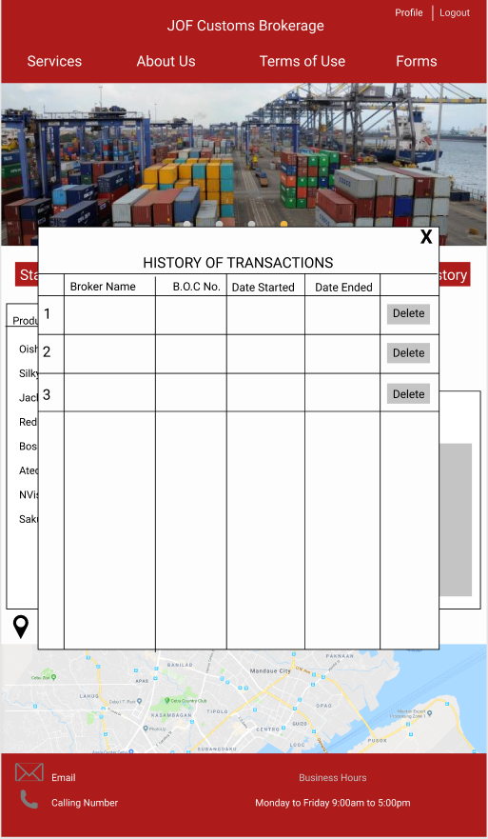

1. **History of Transaction Pop-Up-** this shows the history of transactions made by the user.
2. **Delete Button-** lets user delete a specific transaction history.

**Login/Register Page(Admin)**

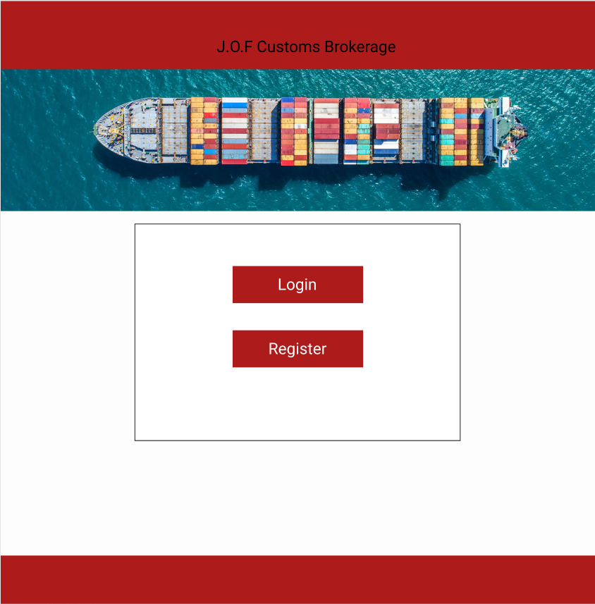

If user is already registered as admin, user may proceed to click login button. If not, register button should be clicked to proceed in signing up.

**Sign Up Form(Admin)**

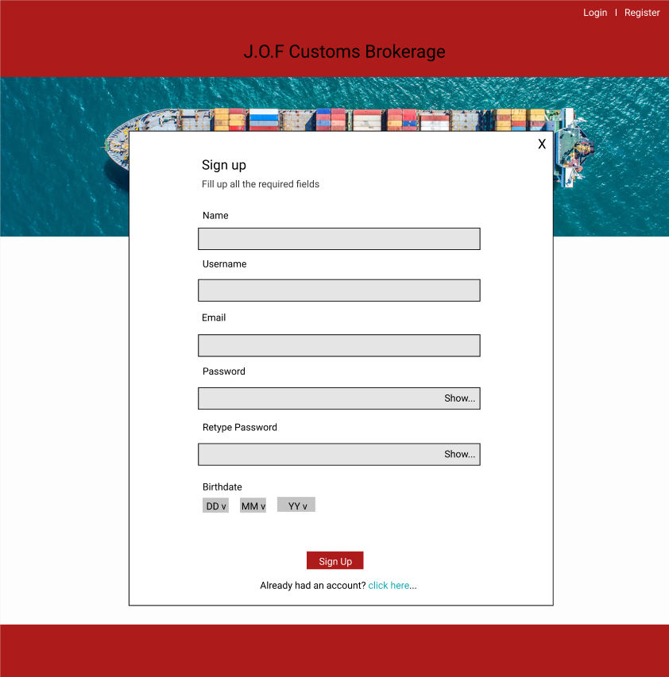

New admin will fill up the following information need to sign up the same way as signing up as a consignee.

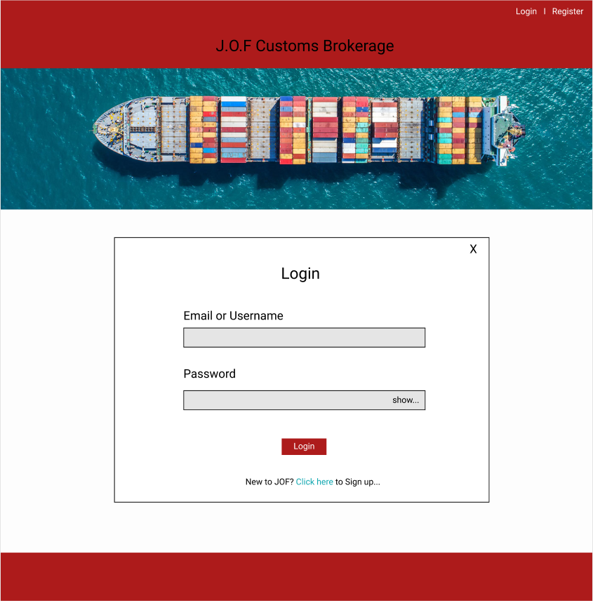**Login Form(Admin)**

Admin is required to input email/username and password before proceeding to login

**Transactions Page(Admin)**

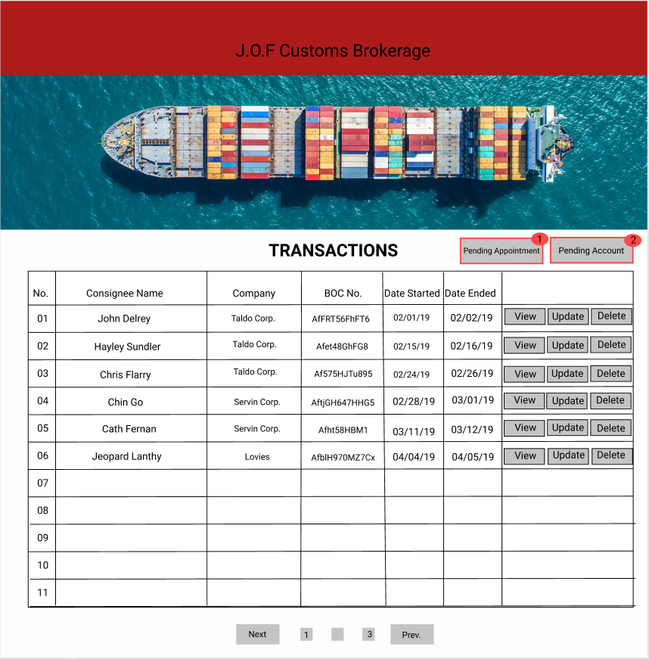

1. **Transactions Page-** contains the consignee’s information.
2. **Pending Appointment Button-** when clicked; it redirects admin to the pending appointments pop-up.
3. **Pending Account Button-** when clicked; it redirects admin to the pending accounts pop-up.
4. **View Button-** admin will be able to view profile of the consignee and packing list.
5. **Update Button-** admin will be able to update status of the consignee’s shipment.
6. **Delete Button-** admin will be able to delete all the information of the consignee

**Admin Profile Settings**

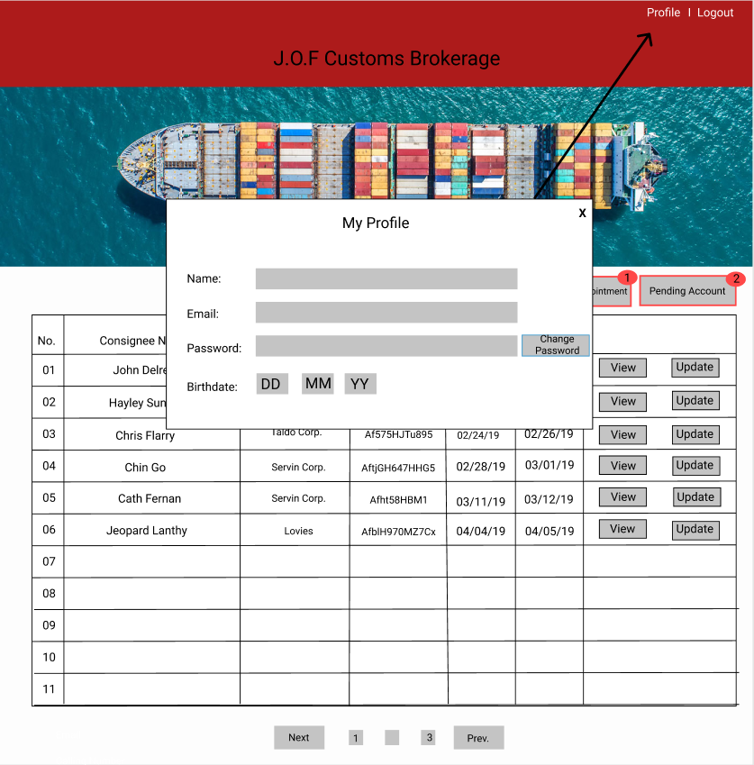

Admin can edit the following info given in the form for his/her account.

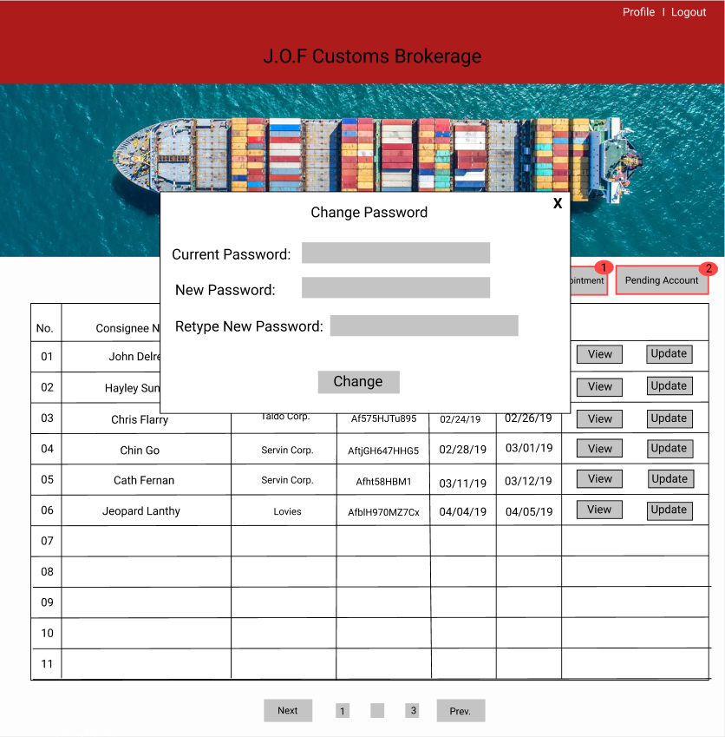

After admin clicked the ‘Change Password’ button, he/she will be redirected to a form that will enable him/her to change for a new password.

**Pending Accounts Pop-Up**

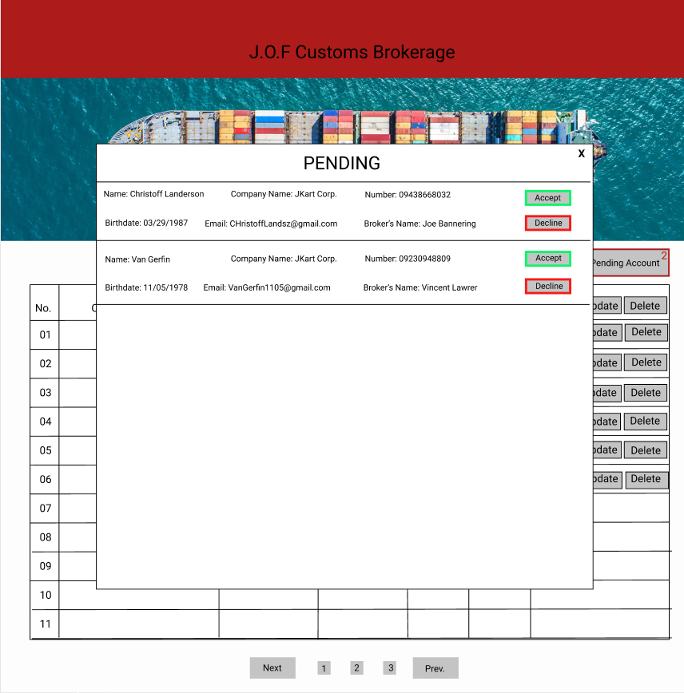

1. **Pending Pop-Up-** it shows the pending accounts waiting for confirmation.
2. **Accept button-** when clicked; user is accepted for appointment.
3. **Decline Button-** when clicked; user is declined for appointment.

**Pending Appointments Pop-Up**

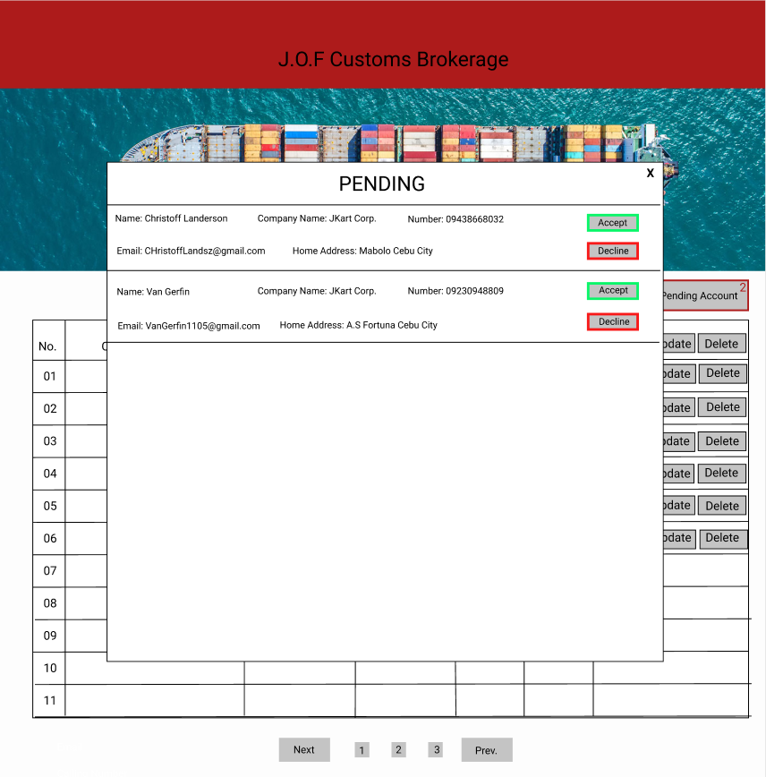

Admin can either accept or decline the pending appointment

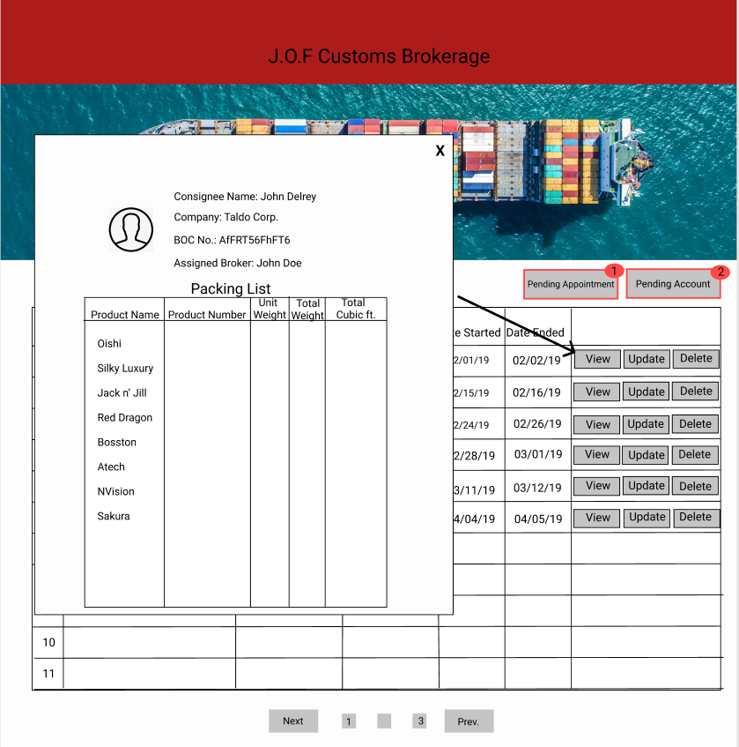**View Button**

Admin will be able to view the consignee’s packing list if the view button is clicked.

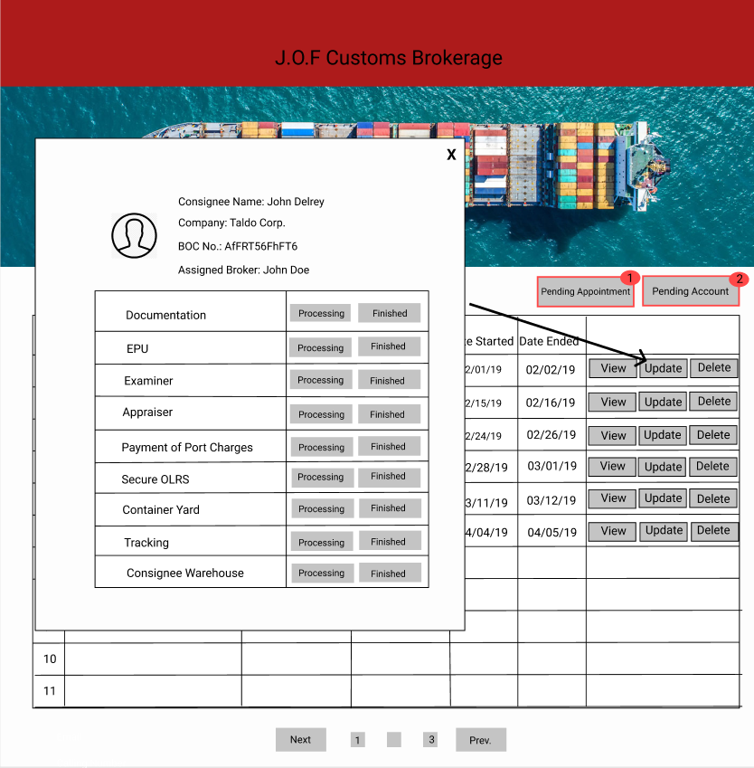**Update Button**

When clicked; a pop up will appear wherein admin will be able to update the status of the consignee’s shipment by clicking a button to choose whether it is still under processing or it’s finished.